STRATFORD HEALTH CENTRE
Patient Group Meeting
8th March 2019
Conference Room, Stratford Health Centre

Chair: Pamela Board (PPG)
Attendees: Stella Damn (PPG)
Jane Brown (PPG)
Steven Brown (PPG)
Anita Foreman (PPG)
Pauline Whitton (PPG)
Christopher Eaton, (General Manager SHC)
Dr Anil Shah, (GP Partner SHC)
Pippa Holdup, (Community Fundraiser, Alzheimer’s Society)

New Member
- Chris Eaton welcomed Pauline Whitton as a new member of the Stratford Health Centre Patient Participaiton Group.
- Pauline has been a Patient at the practice for several years and was introduced to the PPG team.

Alzheimer’s Society
- Pippa Holdup, Community Fundraiser NW London for the Alzheimer’s Society gave a presentation to the team focusing on:
- Her role
- Dementia in the UK
- Support Services – National and Local
- Fundraising week May 2019
- Dementia is being known as the ‘21st Century Killer’ with circa 1million people living with Dementia in the UK alone.
- Pippa discussed her role, the work of the charity and how fundraising is used to support awareness and clinical research as well as providing valuable services to Patients.
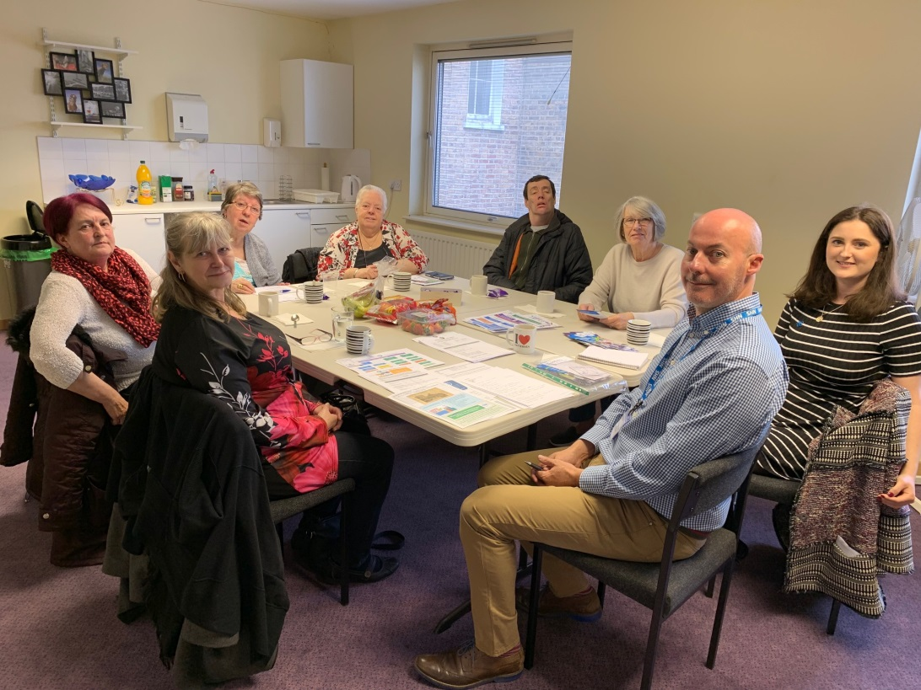
Pippa Holdup from Alzheimer’s Society (pictured on the right) attending our PPG meeting
- Pippa discussed some of the local services available to Newham residents.
- Singing for the Brain (Stratford Library)
- Memory Lane Café’s (East Ham / Canning Town / Manor Park)
- There are also a number of National Services available and a local number available for more details – 0208 472 0658 – newham@alzheimers.org.uk
- Pippa talked about their campaign ‘Life doesn’t end when Dementia begins’ and touched on their fundraising week 20th -26th May 2019 which ties in with their 40th anniversary of the charity
The PPG team and the Practice have agreed to support the pin badge campaign ‘Forget me not’ as one of the fundraising activities and Pippa will be sending badges out shortly
- The PPG and Practice team will review ideas to support the fundraising week locally.
- Pippa asked for consent to use the photo taken above on their corporate Facebook page – this was agreed.

Minutes from last meeting
- Chris Eaton confirmed the minutes with the PPG team from the last meeting (26.10.18).
- Stella asked that Swan Housing were highlighted for their fantastic donation / support to their local charity Christmas meal event.
Practice News – Recruitment
- Chris shared some positive progress on recruitment supporting the Clinical team at Stratford Health Centre
- New Lead Advanced Nurse Practitioner – Maria Espasandin started at the Practice this week. Maria came and introduced herself to the PPG group. She will be working 36 hours a week and is an Independent Prescriber
- New Salaried GP – Dr Philomenia Mridha joins us for 3 session a week later in the month
- New FT Healthcare Assistant, Ashley Tin joins on 18th March
- New FT Physician Associate, Elora Elias joins in 22nd April
- New PT Practice Nurse, Shyra Begum to start in April (date tbc)
- Chris discussed how this will assist appointment availability and allow for more advanced appointments to be booked
- Chris discussed how there was more investment in the Adminsitration team to filter clinical documents and support referral management and in essence this was supporting the clinical teams administration workload.
Practice News – DNA’s (did not attend)
- Chris discussed the DNA statistics for last year
- Overall the Practice had 2,187 DNA’s – this is equivalent to 11% of total appointments at the Practice.
- From a GP perspective – this is equivalent to 121 whole GP session which equates to a GP working FT for 13.5 weeks
- Chris discussed the actions the Practice was taking to drive awareness and follow up with the Patients that DNA on a frequent basis.

Practice News – Patient feedback
- Chris confirmed the Practice was now achieving 3.5 stars on NHS choices (the Trip Advisor of Primary Care) – this has increased from 2 stars six months ago.
- The Practice team are proactively encouraging Patients to leave feedback on the website when positive comments are received.
- The Practice is also collating a Patient Survey and has had over 250 responses. Chris will share the detail at the next meeting but indicated a number of positive comments have been received about improvements Patients have seen.
- The biggest challenge is still telephone access and Chris / Dr Shah have committed to making some changes in due course to address this.
Practice News – Awareness campaigns
- Chris discussed current NHS / PHE’s campaigns that are being supported by the Practice.
- A Public Health England (PHE) campaign launched this week to focus on cervical screening.
- This is currently at a 20 year low and 2 women die every day in the UK
- Big awareness campaign launched to support testing / early diagnosis and ultimately save lives
- Stratford Health Centre supporting this with internal posters / website messaging / patient recalls and looking at a ‘wear purple day’ with the Practice Team
- Chris also discussed the NHS campaign ‘Help Us Help You’ focusing on minor ailments that could be treated by a Pharmacist to free up GP appointments. NHS research shopws that nearly a third of all appointments could have been treated successfully at the local pharmacy
- To confirm any Patients who are exempt from prescription charges can be presribed medication free of charge at the Pharmacy as part of the NHS minor ailments scheme
Practice News – New Contract
- Chris shared some highlights of the new NHS 5 year contract for General Practice
- The practice will be asked to join a ‘Primary care Network’ (PCN) by 1st July 2019 and be part of a 30,000 – 50,000 Patient network by joining with other local practices
- A number of shared services / resources will be delivered by the PCN
- More details will be provided at the next meeting as this will be nearer the launch

PPG Team Feedback
- The PPG team talked positively about their experience of the Advanced Nurse Practitioners at Stratford Health Centre
- Stella was also positive about her experience of referrals following her appointment with Matthew Keri (ANP)
- The PPG team supported the internal Patient Survey and these were collected by Chris
- The PPG team endorsed the issue with telephone access and once again Chris / Dr Shah confirmed this will be addressed shortly and recognise the need for investment / improvement
- The team asked about the possibility of weekend opening. Chris discussed the new service available where the Practice can book our Patients into the Newham 8-8 service at weekends. Chris also mentioned that extened hours are likely to be a new requirements as part of the new contract / PCN structure but details would be confirmed in due course.
Actions
- PPG to discuss fundraising activities to support Alzheimer’s week
- PPG to support the selling of pin badges within the community (Pippa will send directly to Anita)
- Next meeting – May 2019
- CE / AS to review telephone contract and systems
- CE to collate Patient Survey results and produce Executive Summary and recommendations

